**Section 16**

**DP 16.1:**

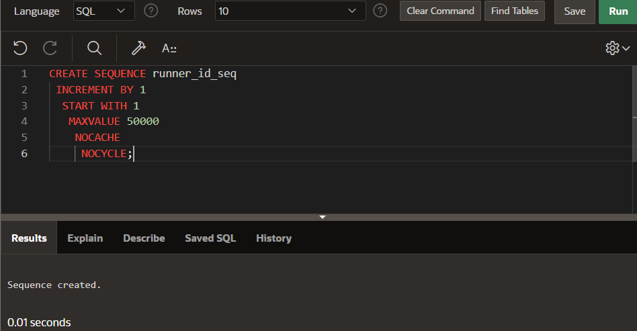

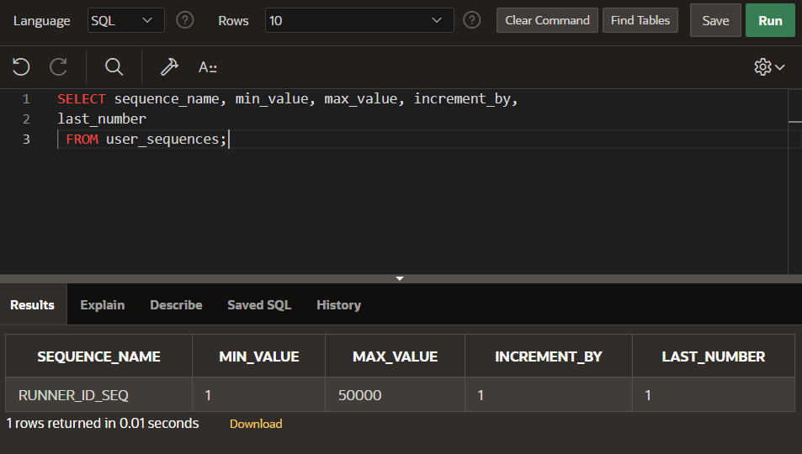

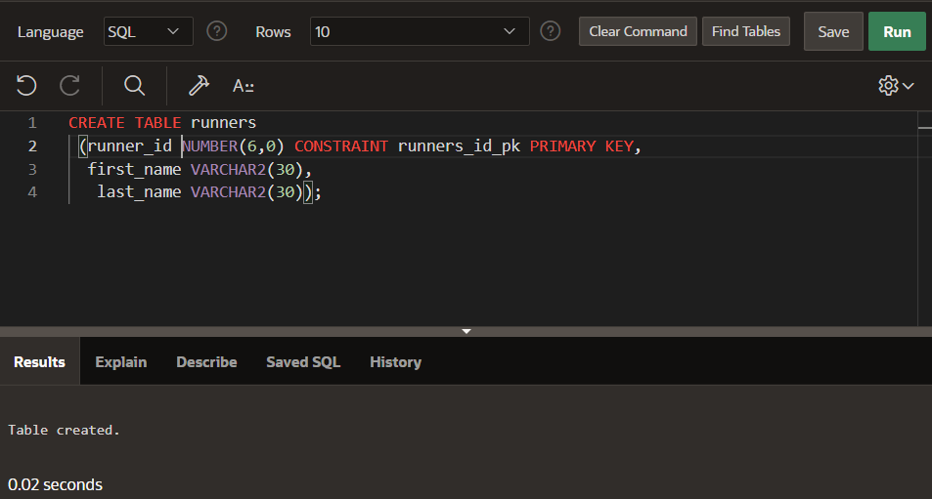

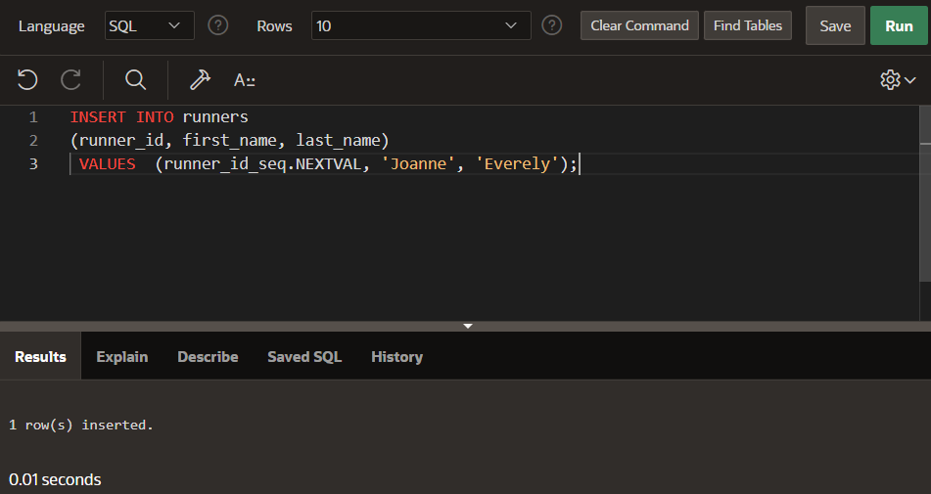

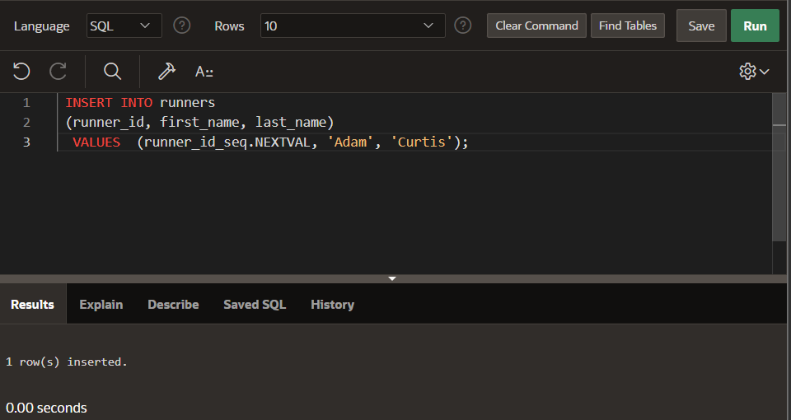

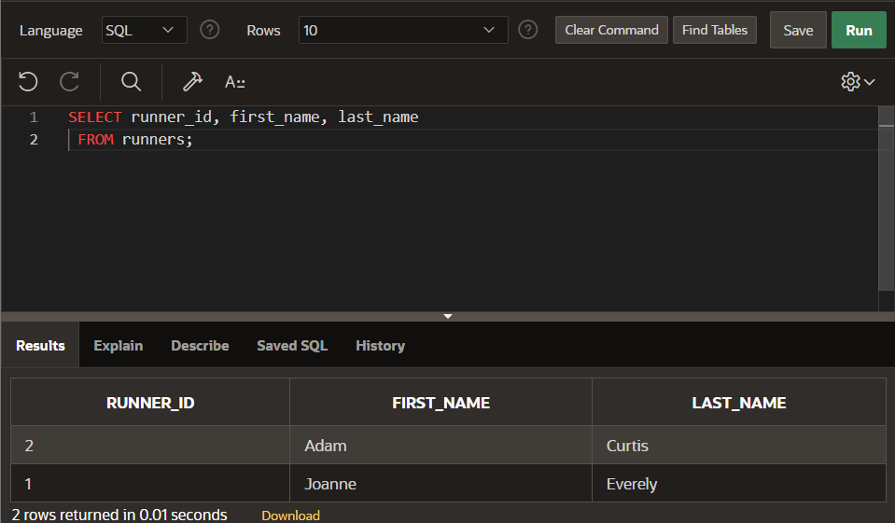

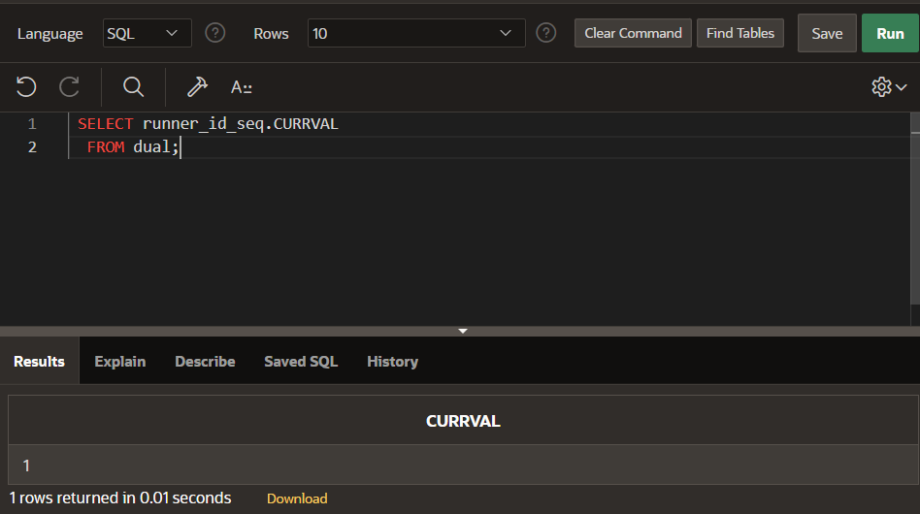

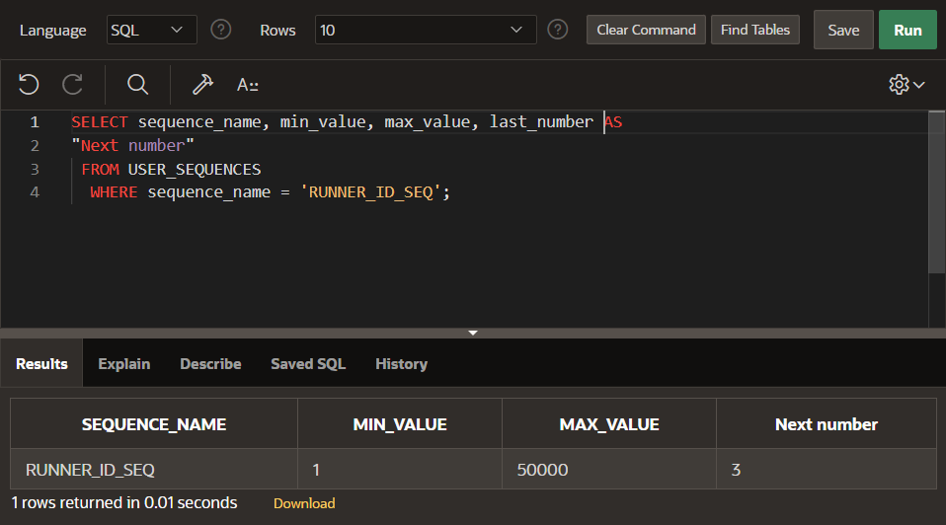

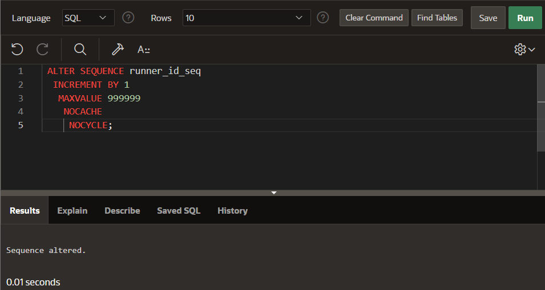

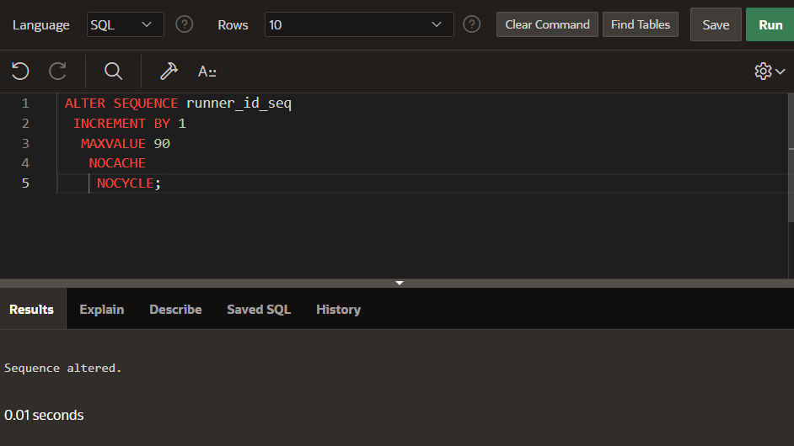

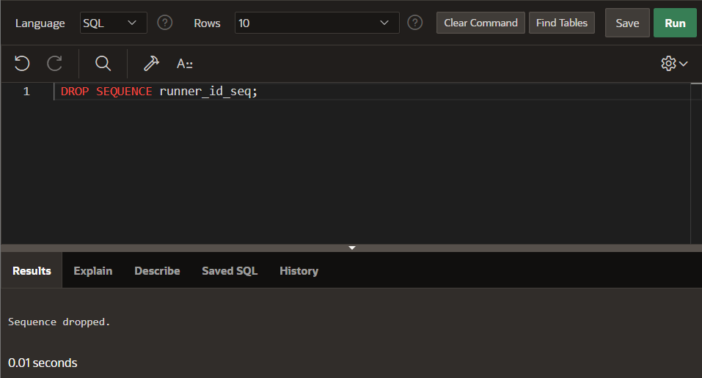

**DP 16.2:**

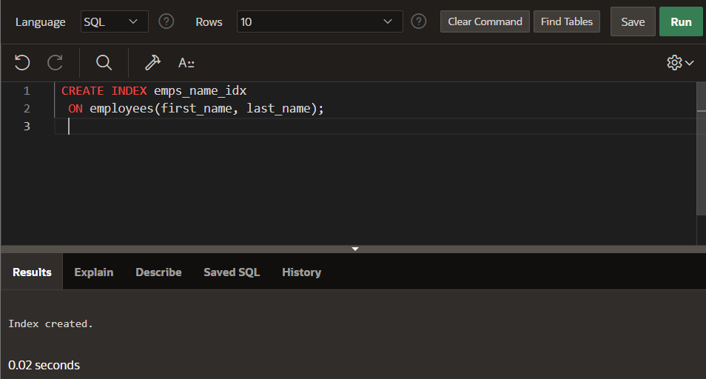

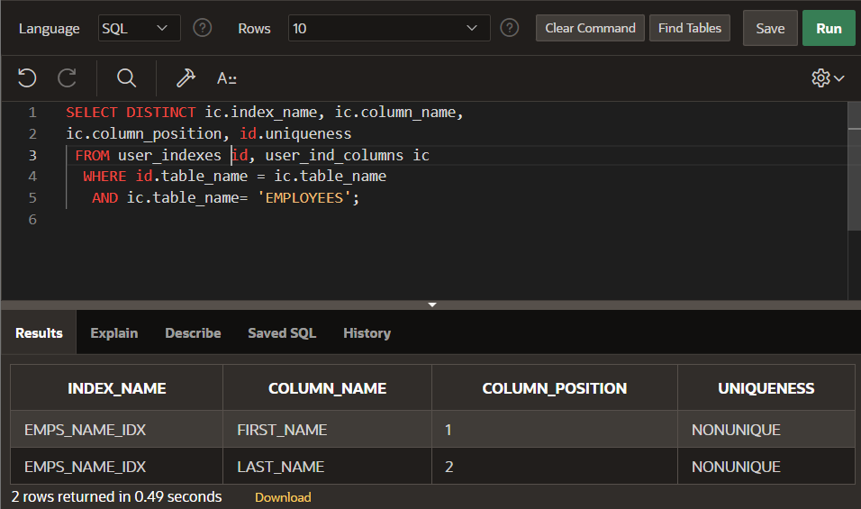

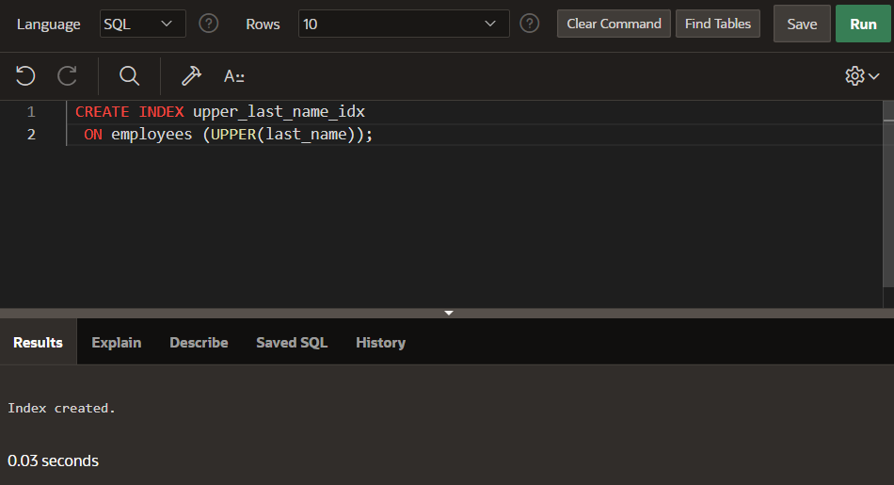

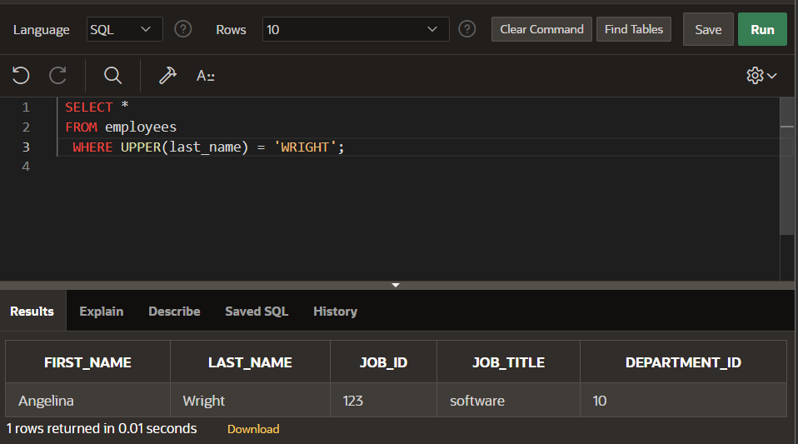

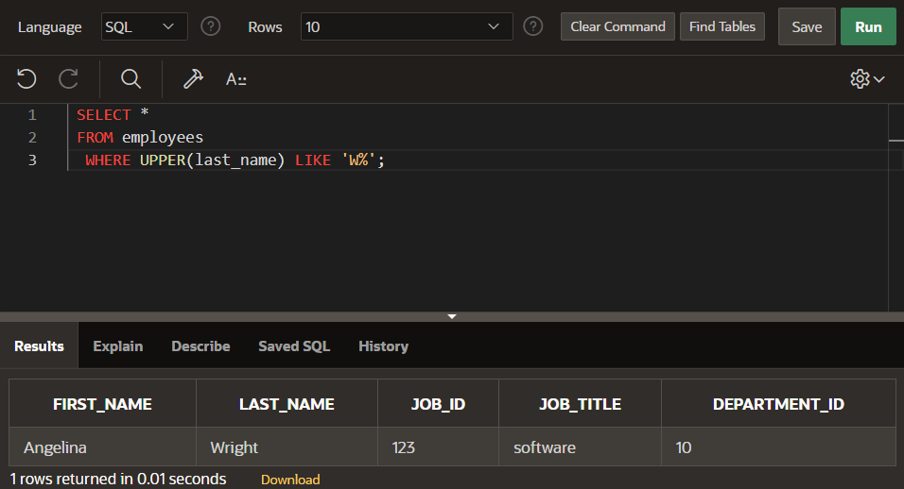

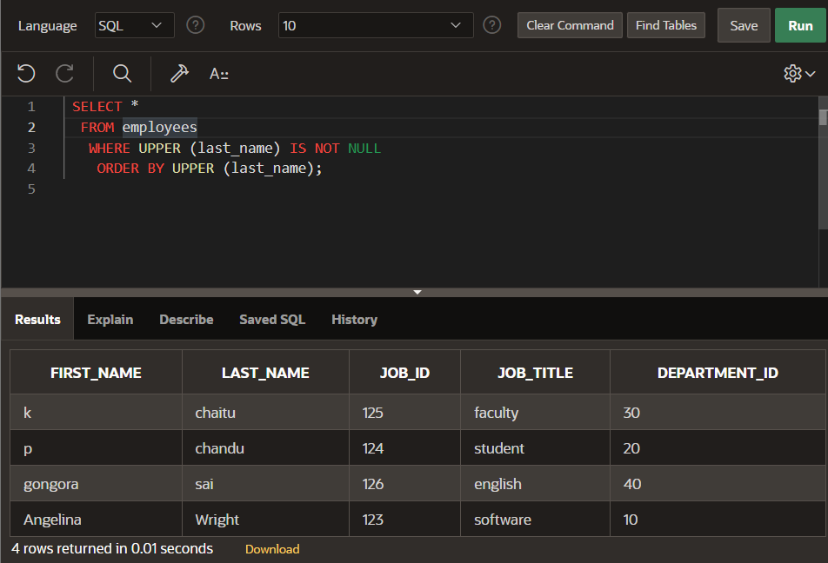

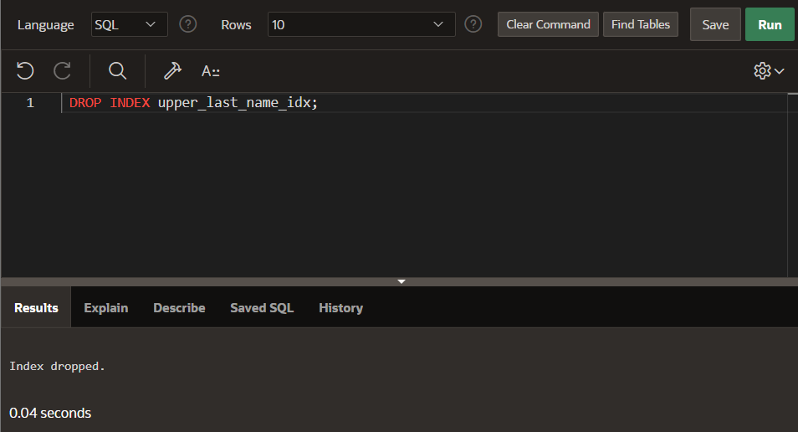

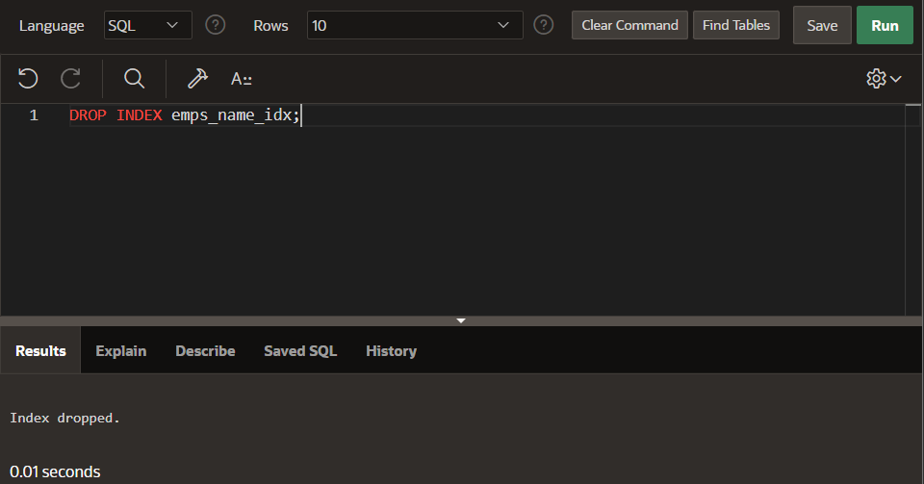

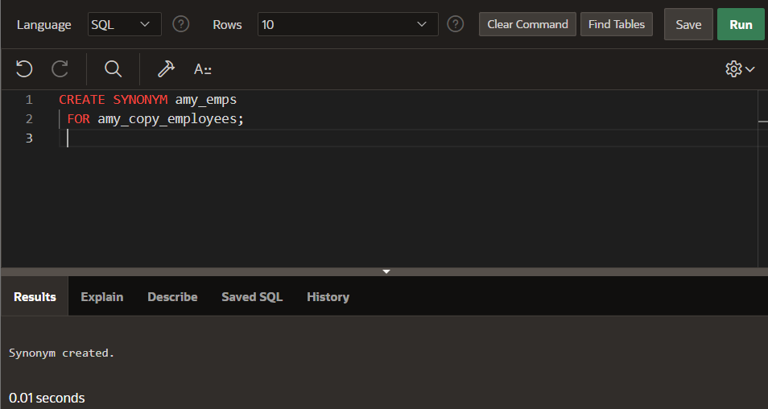

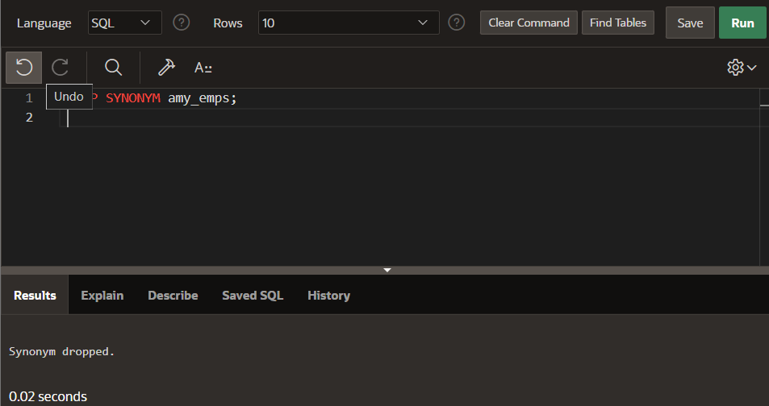

**Section15**

**DP 15.1:**

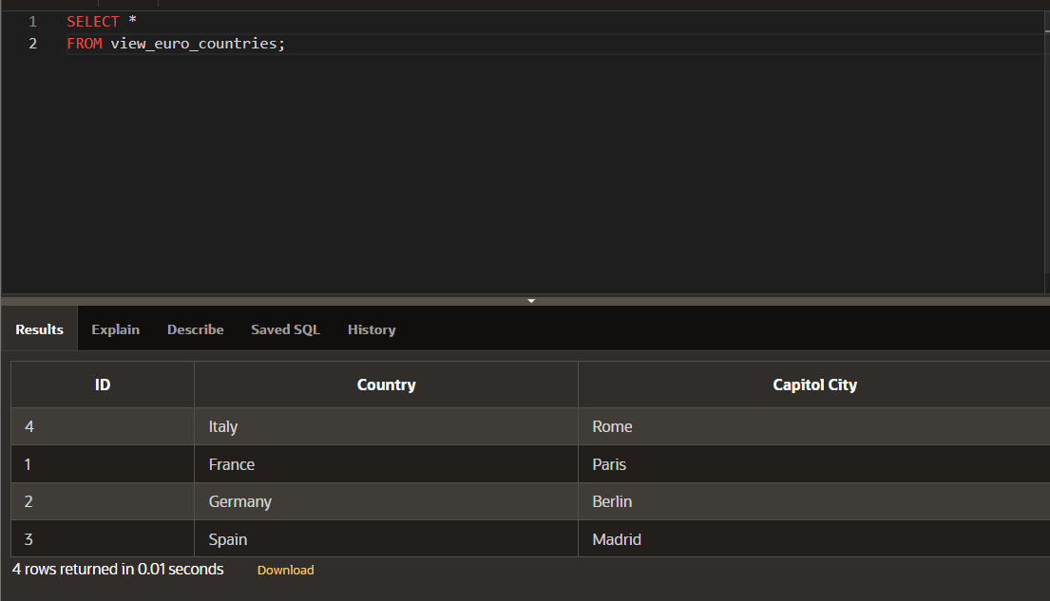

**DP 15.2:**

**DP 15.3:**

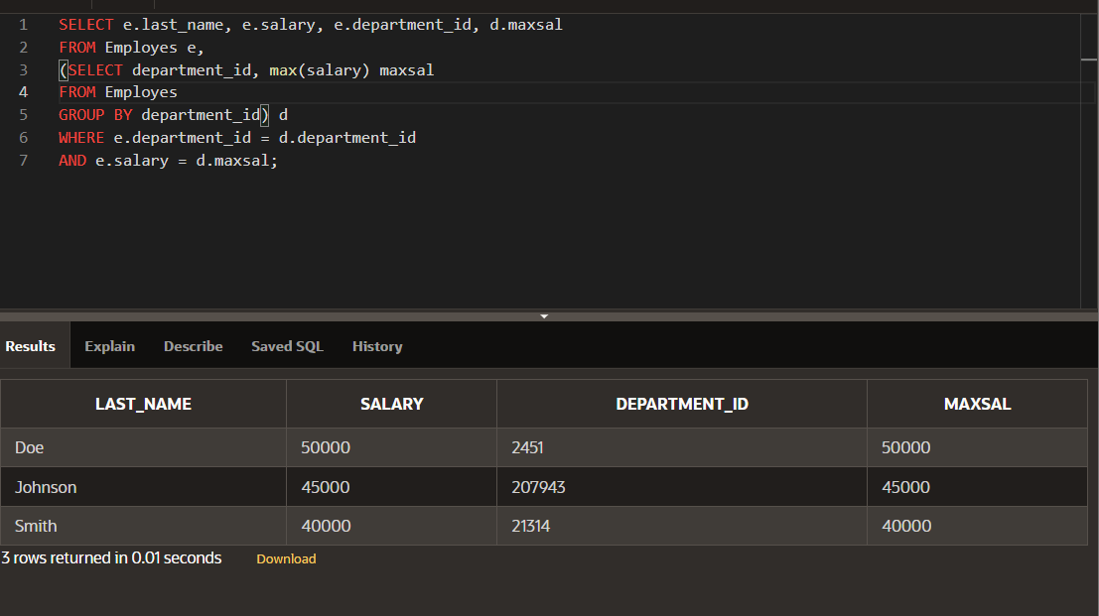

**Section14**

**DP 14.1:**

**1.create a table:**

**CREATE TABLE clients**

**(client_number NUMBER(4),**

**first_name VARCHAR2(14),**

**last_name VARCHAR2(13)**

**);**

**2.creating constraints:**

**CREATE TABLE client**

**(client_number NUMBER(4) CONSTRAINT clients_client_num_pk PRIMARY KEY,**

**first_name VARCHAR2(14),**

**last_name VARCHAR2(13));**

**3.constraints at the column level**

**CREATE TABLE clients1**

**(client_number NUMBER(4) CONSTRAINT clients_cient_num_pk PRIMARY KEY,**

**last_name VARCHAR2(13) CONSTRAINT clients_last_name_nn NOT NULL,**

**email VARCHAR2(80) CONSTRAINT clients_emil_uk UNIQUE**

**);**

**4.user name constraint and system name constraint:**

**CREATE TABLE clie**

**(client_number NUMBER(4) CONSTRAINT clie_clie_num_pk PRIMARY KEY,**

**last_name VARCHAR2(13) NOT NULL,**

**email VARCHAR2(80));**

**5.constraints at the table level:**

**CREATE TABLE clien (**

**client_number NUMBER(6) NOT NULL,**

**first_name VARCHAR2(20),**

**last_name VARCHAR2(20),**

**phone VARCHAR2(20),**

**email VARCHAR2(10) NOT NULL,**

**CONSTRAINT clients_phone_email_uk UNIQUE (email,phone)**

**);**

**6.violation:**

**CREATE TABLE clients(**

**client_number NUMBER(6),**

**first_name VARCHAR2(20),**

**last_name VARCHAR2(20),**

**phone VARCHAR2(20) CONSTRAINT phone_email_uk UNIQUE(email,phone),**

**email VARCHAR2(10) CONSTRAINT NOT NULL,**

**CONSTRAINT emailclients_email NOT NULL,**

**CONSTRAINT clients_client_num_pk PRIMARY KEY (client_number)**

**);**

**7.unique constraint example:**

**insert into clients4(client_number,first_name,last_name,phone,email)**

**values (01,vishnu,chaithanya,564123,'vishnu@123');**

**insert into clients4(client_number,first_name,last_name,phone,email)**

**values (02,pusalapati,chandu,54896,'chandu@123');**

**insert into clients4(client_number,first_name,last_name,phone,email)**

**values (03,'gongora','sai',5549864123,'vishnu@123');**

**8.composite unique:**

**insert into clients5(client_number,first_name,last_name,phone,email)**

**values (01,rv,saai,246,'abced@123');**

**insert into clients5(client_number,first_name,last_name,phone,email)**

**values (02,chandu,raj,5647589,'abcd@123');**

**insert into clients5(client_number,first_name,last_name,phone,email)**

**values (03,'abcd','sai',564789,'abcd@123');**

**DP 14.2:**

**Primary key:**

**CREATE TABLE client**

**(client_number NUMBER(4) CONSTRAINT clients_client_num_pk PRIMARY KEY,**

**first_name VARCHAR2(14),**

**last_name VARCHAR2(13));**

**Constraints at the table level(primary key):**

**CREATE TABLE cli**

**(client_number NUMBER(4),**

**first_name VARCHAR2(14),**

**last_name VARCHAR2(13),**

**CONSTRAINT cli_num_pk PRIMARY KEY (client_number));**

**primary key constraint:**

**CREATE TABLE copy_job_history**

**(employee_id NUMBER(6,0),**

**start_date DATE,**

**job_id VARCHAR2(10),**

**department_id NUMBER(4,0),**

**CONSTRAINT copy_jhist_id_st_date_pk PRIMARY KEY(employee_id,**

**start_date));**

**foreign key:**

**CREATE TABLE copy_employees**

**(employee_id NUMBER(6,0) CONSTRAINT copy_emp_pk PRIMARY KEY,**

**first_name VARCHAR2(20),**

**last_name VARCHAR2(25),**

**department_id NUMBER(4,0) CONSTRAINT c_emps_dept_id_fk**

**REFERENCES departments(department_id),**

**email VARCHAR2(25));**

**Section13**

**DP 13.1:**

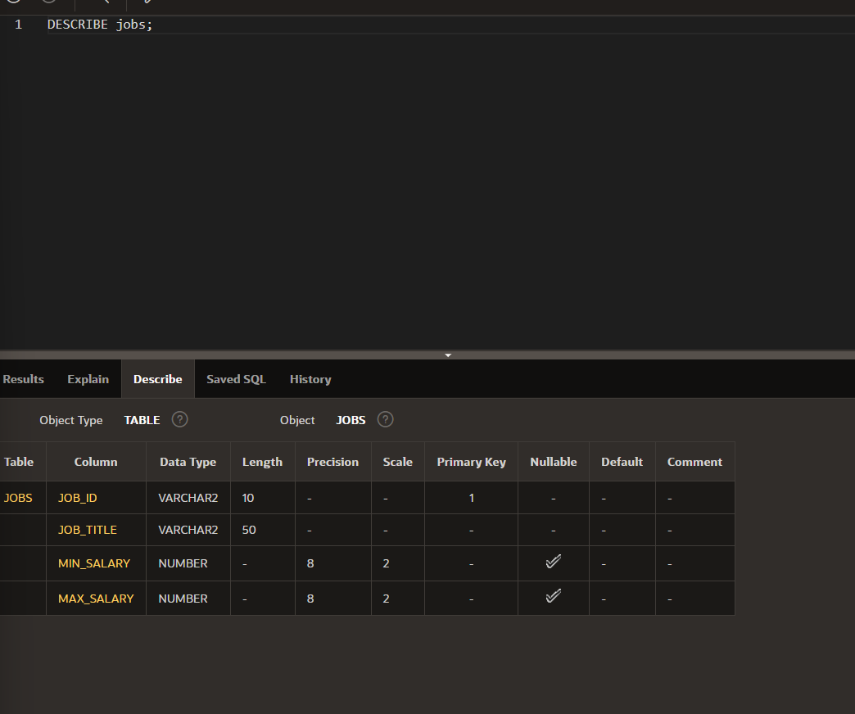

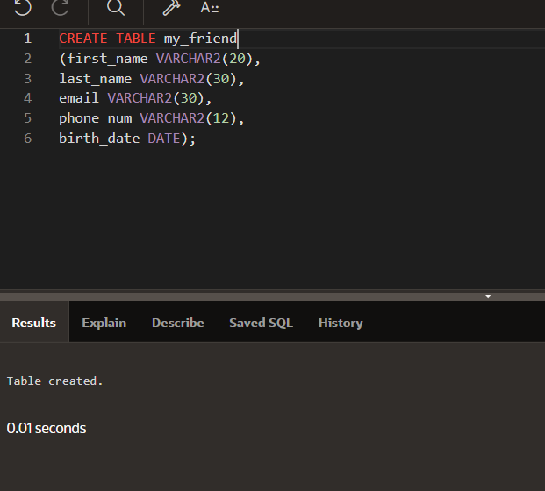

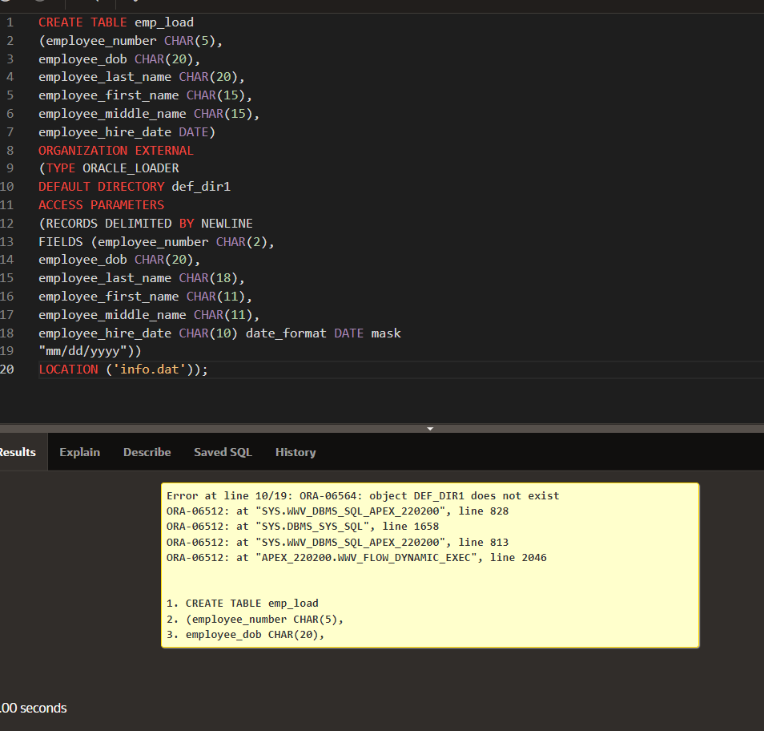

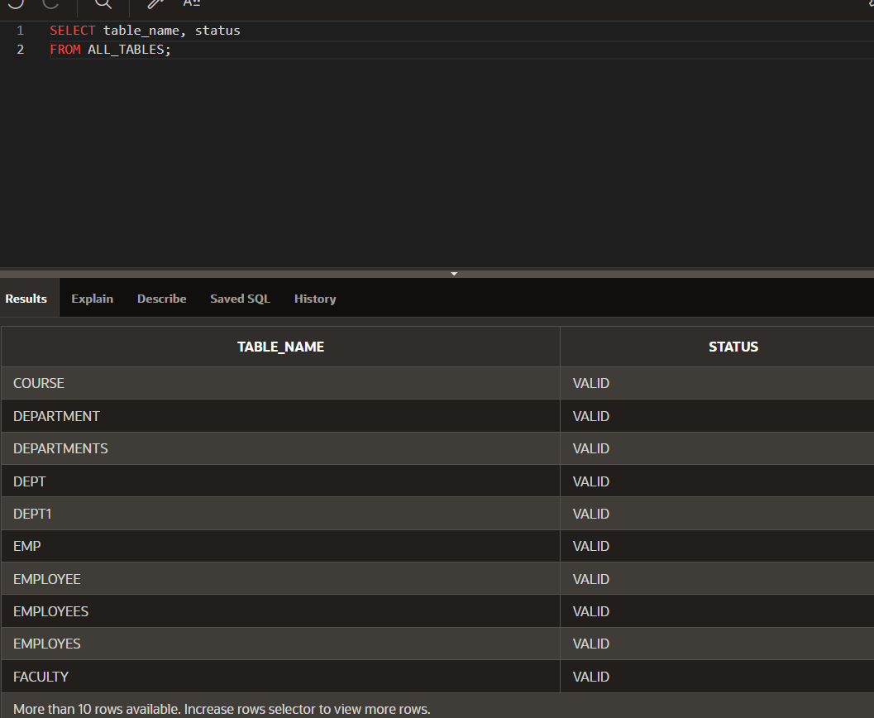

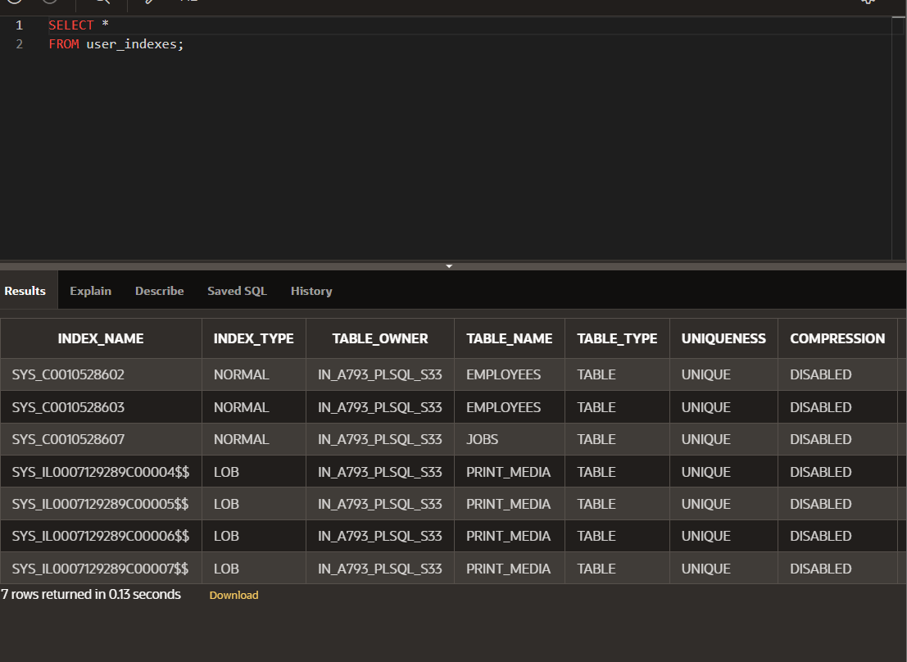

**DP 13.2:**

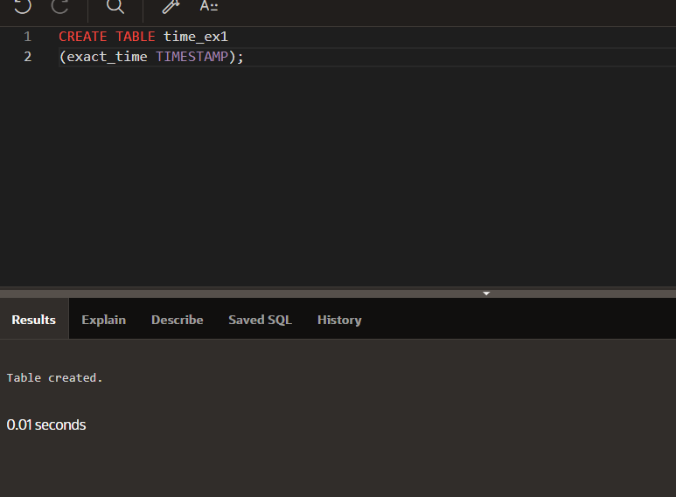

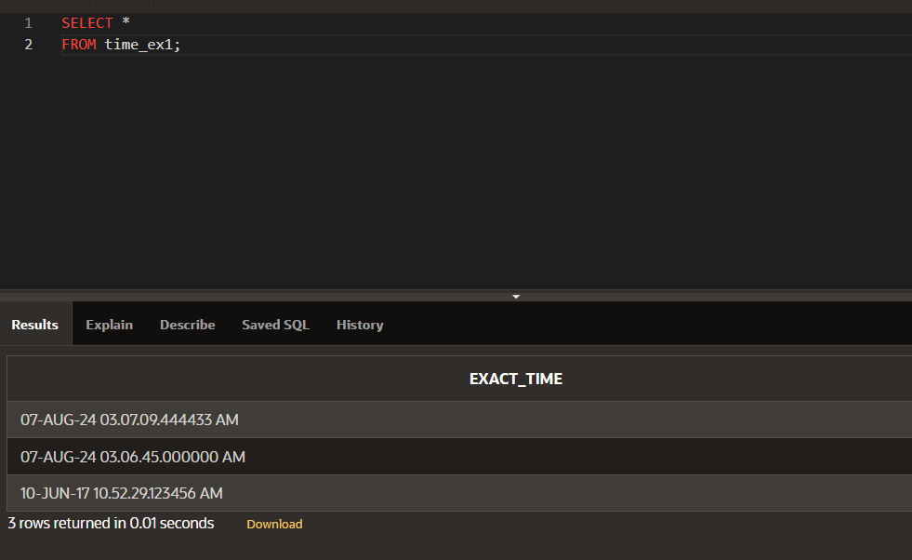

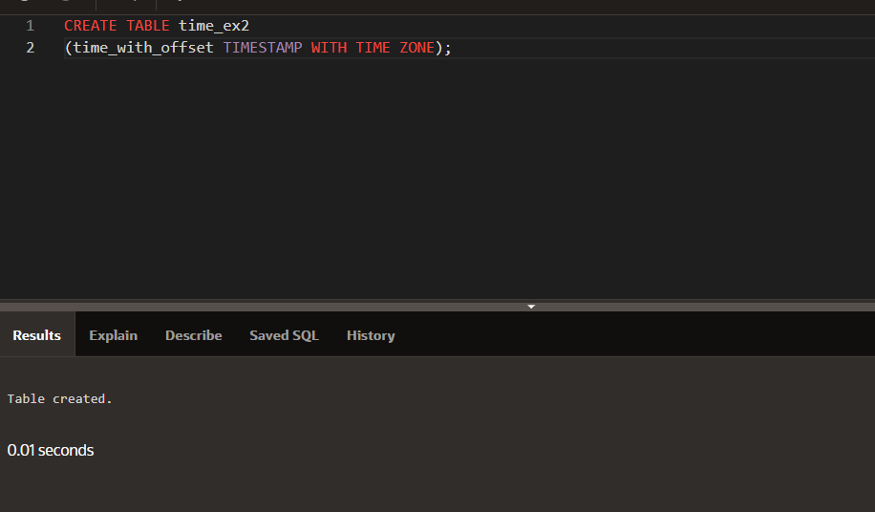

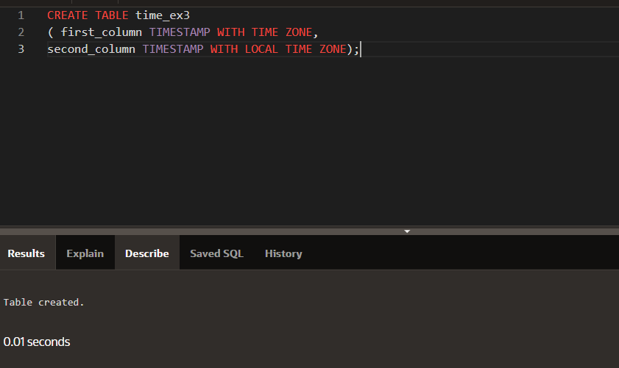

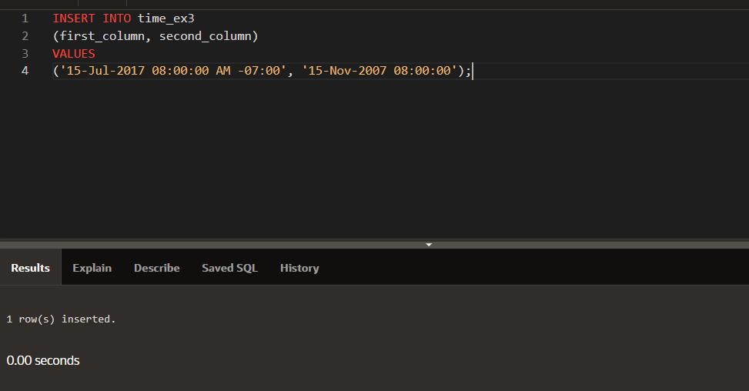

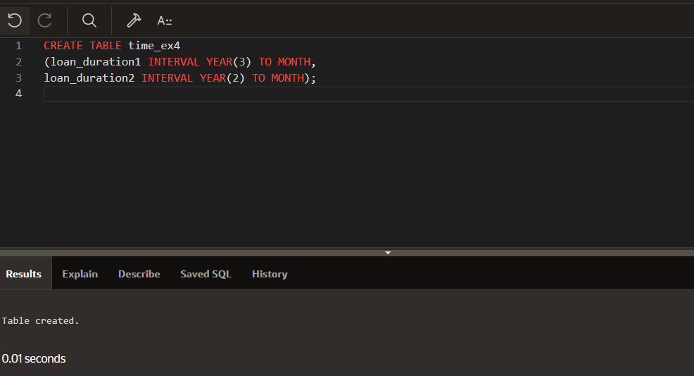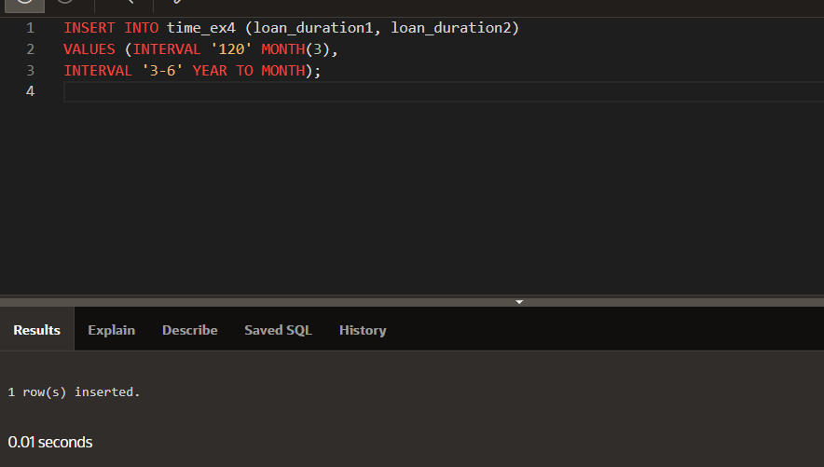

**DP 13.3:**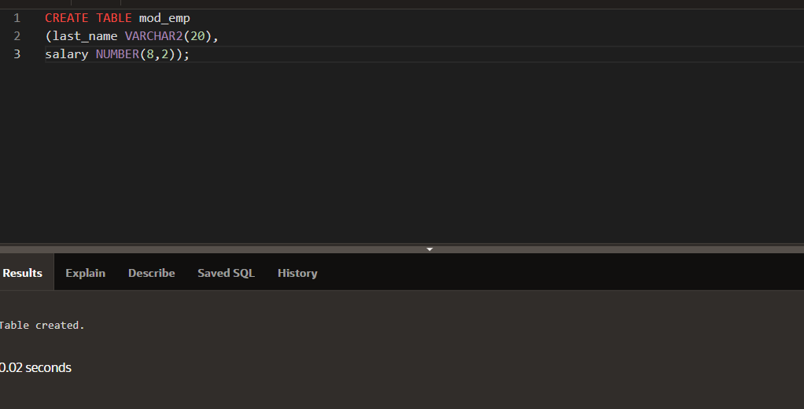

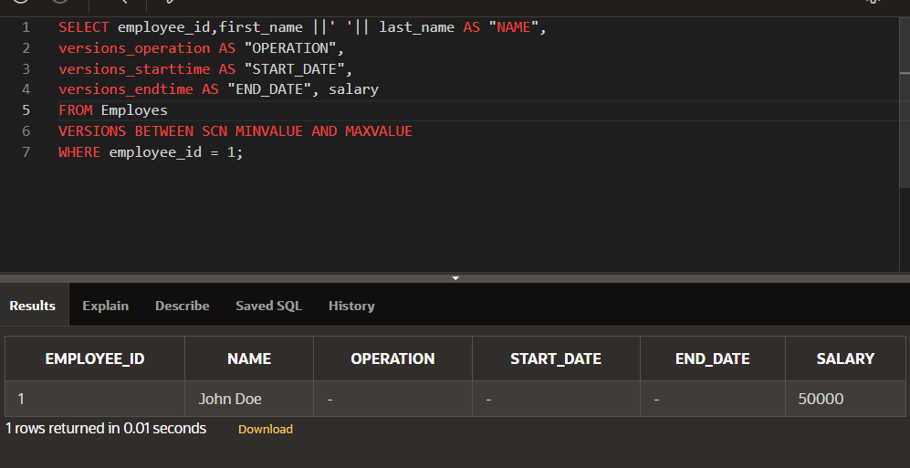

12_1



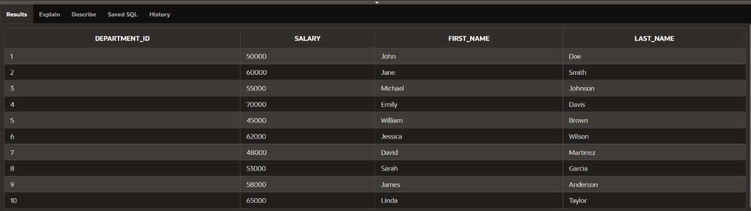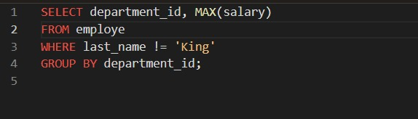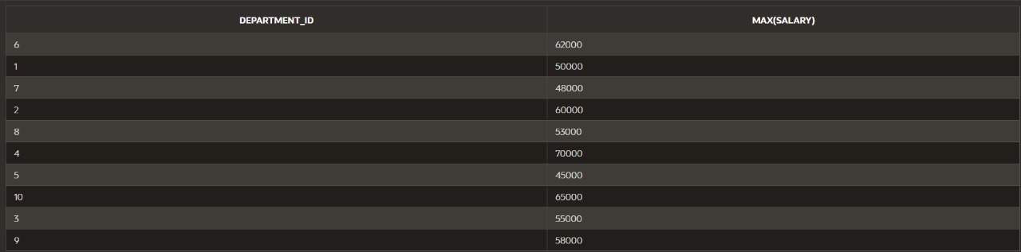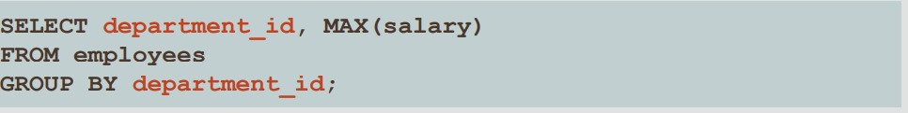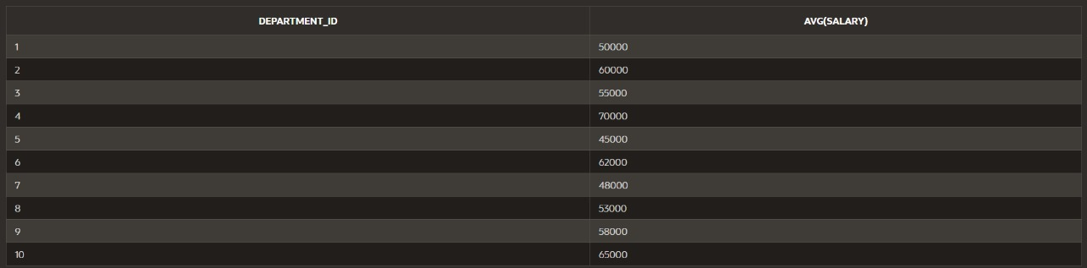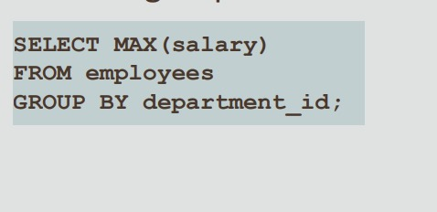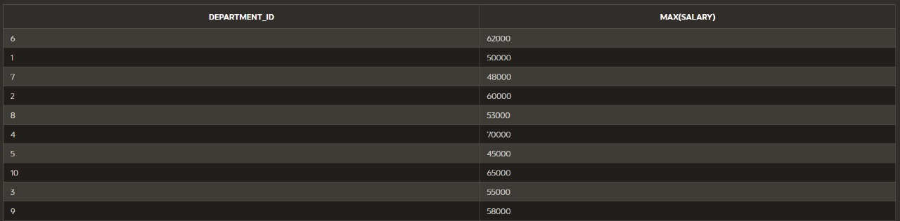

Dp 12_2

UPDATE copy_employees

SET phone_number = '123456'

WHERE employee_id = 3;

SELECT *FROM COPY_EMPLOYEZ

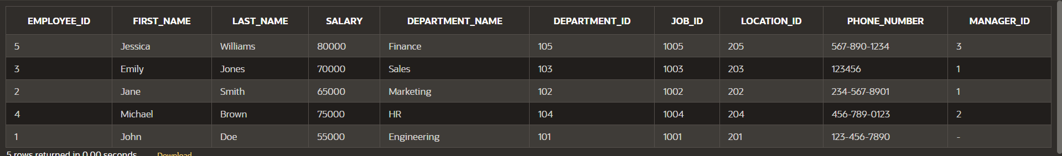

UPDATE copy_employeZ

SET phone_number = '654321',

WHERE last_name = 'Jones'

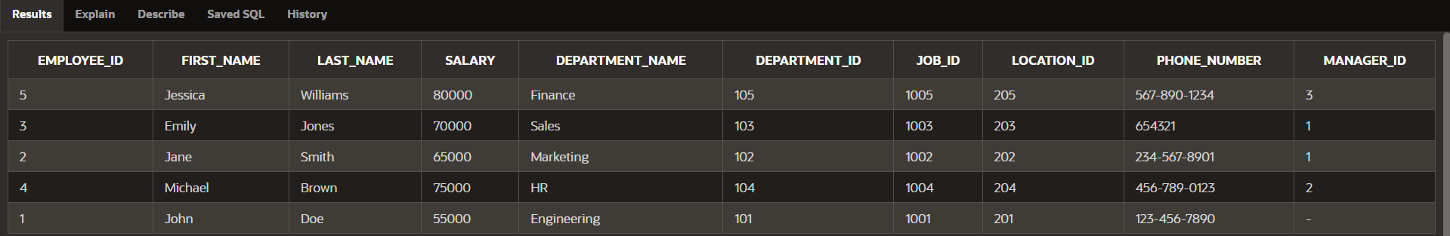

UPDATE copy_employeZ

SET salary = (SELECT salary

FROM copy_employeZ

WHERE employee_id = 1)

WHERE employee_id = 2;

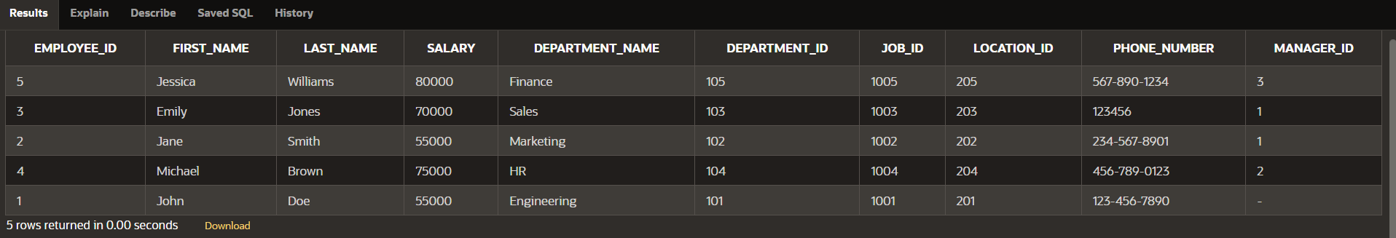

UPDATE copy_employeZ

SET salary = (SELECT salary

FROM copy_employeZ

WHERE employee_id = 4),

job_id = (SELECT job_id

FROM copy_employeZ

WHERE employee_id = 2)

WHERE employee_id = 3;

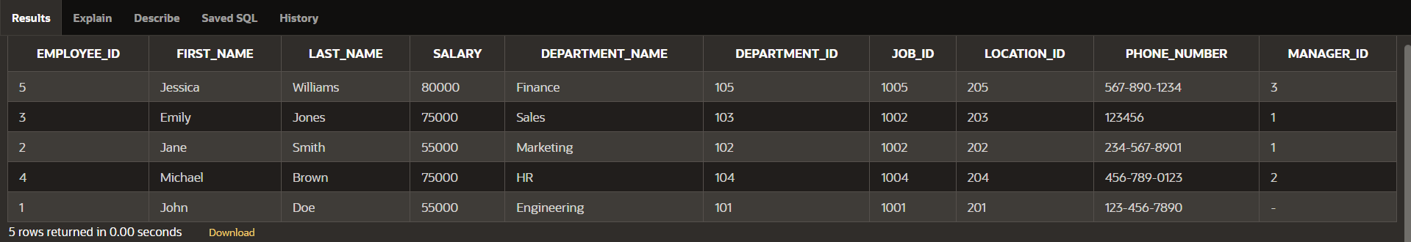

DELETE from copy_employeZ

WHERE employee_id = 3;

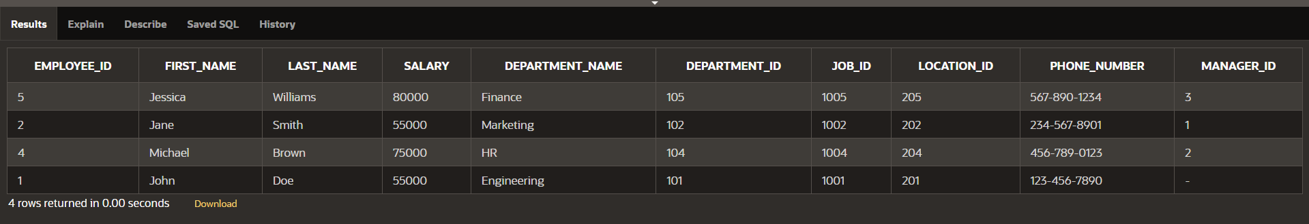

MERGE INTO copy_emp c USING employees e

ON (c.employee_id = e.employee_id)

WHEN MATCHED THEN UPDATE

SET

c.last_name = e.last_name,

c.department_id = e.department_id

WHEN NOT MATCHED THEN INSERT

VALUES (e.employee_id, e.last_name, e.department_id);

12_3

INSERT INTO my_employees

(hire_date, first_name, last_name)

VALUES

(DEFAULT, 'Angelina', 'Wright');

INSERT INTO my_employees

(first_name, last_name)

VALUES

('Angelina', 'Wright');

UPDATE my_employees

SET hire_date = DEFAULT

WHERE last_name = 'Wright';

